UPDATE: 10-27-25 Documentation

Food Pricing Data Pull Update & QA Framework Proposal

Made significant progress on:
1. python library errors
2. preventing timeout errors
3. automation architecture and execution
4. logging system
5. Execution speed and error notification
Why The delay stems from necessary infrastructure changes — particularly the need to stabilize how our R and Python environments communicate, how credentials are handled, and how the multiple scrapers interact with Google Drive’s long paths and folder structures.
These issues have compounded over time, and while they don’t sound dramatic, they represent hundreds of lines of brittle code that required re-engineering. I’ve focused on making the system more transparent, log-driven, and recoverable — even if that meant slower short-term progress.
WHAT’S WORKING SO FAR:
• Unified control script: The new central_food_pull.R launches all store scrapers (ACC, Fred Meyer, Walmart, and hopefully soon CS) under one framework.
• Reproducible environment: Python dependencies are now isolated in a controlled virtual environment to avoid version conflicts.
• Credential handling: Kroger and Bright Data credentials are injected securely at runtime instead of stored in source code.
• Structured logging: Each store generates its own log, plus a central 'runner' summary with timestamps and tracebacks.
• Automation-ready batch file: The .bat launcher now runs manually or via Windows Task Scheduler with no manual setup.
Transition Update:
ISER_DataTeam@alaska.edu has been added to the Kroger developer organization profile as a user. This ensures I’m not the only one able to manage credentials or application settings in the future and gives ISER shared administrative access for continuity.
WHY THIS IS STILL SLOW:
The system is still sensitive because our data sources are inherently unstable. Both Kroger’s API and Walmart’s Bright Data layer are evolving their security and access patterns, which can suddenly break running code. The Bright Data portion alone has been an active two-month effort, and it remains the most volatile component.
While the structure is now sound, there will continue to be occasional interruptions driven by external changes. My goal has been to ensure that when those failures occur, they’re visible and logged, rather than silent or destructive.
This is also the first time we’ve consolidated everything into a reproducible, cross-language data pipeline — something that’s much closer to full data engineering than analytics work — and the learning curve has been steep.
QA STATUS:
My own QA layer — originally written in RMarkdown to check for duplicates, pricing gaps, cross-store consistency, etc. —was work in progress that continually lagged behind the growing requirements of data collection. Because the file paths, logging definitions, and data export locations have changed so substantially, the existing QA scripts will need to be refactored to align with the new structure. That will take additional time.
Given this, it makes sense for Carolyn to design a more formal QA schema in SQL Server, where validation can happen independently of the pipeline itself.
This would also have the benefit of establishing a cleaner division of responsibility and expertise:
Vanessa — Pipeline automation, scraping, and environment management
Carolyn — SQL-based QA schema, data validation, and dashboard development
Carolyn can work on the QA dashboard in PowerBI if she has time, if not, I will need a project to learn PowerBI on anyway. :-)
Obviously cross-training needs to take place at some point and I will begin to set aside more dedicated time to documentation the processes and data architecture so we (as well as stakeholders) can more easily work with and rely on this data. But I can't stress enough that doing this right takes focus and time.
INFRASTRUCTURE & BURNOUT NOTE:
A recurring source of delay — and personal burnout — has been Google Drive’s path limitations and sync behavior. Every run must write multiple log and data files through nested shared-drive paths, which introduces constant fragility and path-length errors.
Ultimately, this points to the need for a permanent solution such as Snowflake or another centralized data warehouse, where structured storage and access controls eliminate these issues entirely. Until that transition occurs, the current setup will always involve a degree of manual maintenance and troubleshooting.
LOOKING AHEAD:
• The Fred Meyer scraper ran successfully this weekend.
• The Walmart (Bright Data) pull is currently running and logging correctly, though it remains sensitive to Bright Data queue and timeout behavior.
• I’ll continue stabilizing and documenting everything for handoff before any extended leave (if at all possible).

LOGS

DATA AVAILABILITY

BRIGHT DATA

BACK CATALOG
https://docs.brightdata.com/datasets/archive/overview

Bright Data’s Archive API has collected data since its launch, covering billions of URLs and domains. The exact historical depth for Walmart data in Alaska depends on when Walmart pages were first captured and how frequently they’ve been updated. Generally, the Archive contains data going back several months to over a year, but coverage may vary by domain and region.
Delivery time:
- If your query matches data from the last 72 hours, delivery is typically immediate.
- For data older than 72 hours, retrieval may take up to 72 hours, as it’s fetched from cold storage.
Filtering for Walmart and Alaska: You can filter the dataset by domain (Walmart) and location (Alaska) using the Archive API or the Dataset Marketplace. This ensures you only receive relevant records.
Reference:
- Archive API Overview
- Archive API FAQs
If you want to browse or purchase pre-collected Walmart data, you can use the Walmart dataset.
For custom, fresh data collection, use the Walmart web scraper.
Do you need pre-collected or fresh data?

NEW FEATURES

- AUTOMATED PULL FAILURE NOTIFICATIONS, LOGS.
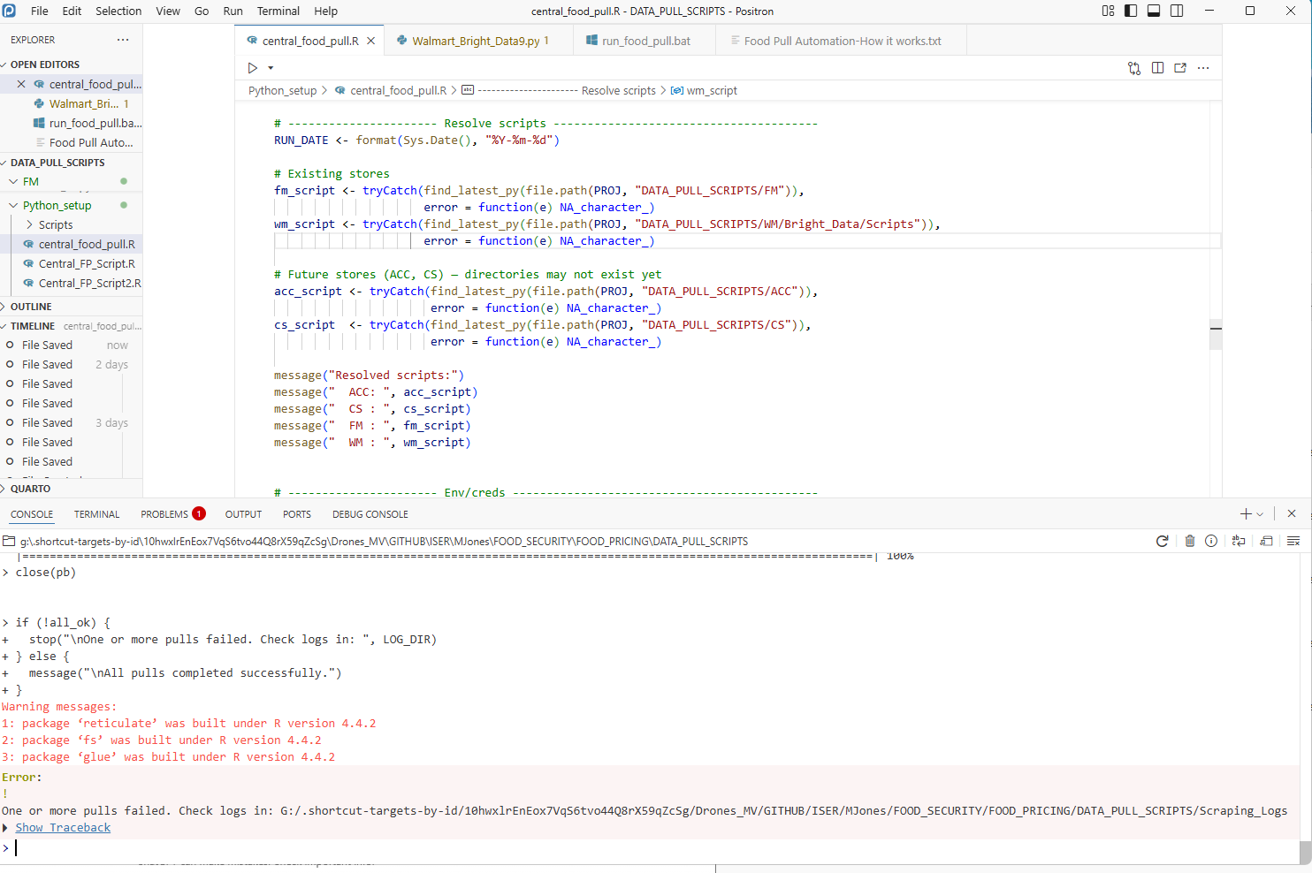

How this pipeline works - an overview
LOCATION for automation and Python components

Outline
Title: Food Pricing Data Pull — Technical Overview and Next Steps
Sections:
- Purpose
  - Describe goal: unify all store scrapers (FM, WM, ACC, CS) into a single reproducible pipeline.
  - Reduce manual work and human error.
- System Components
  - central_food_pull.R — orchestrates Python scrapers.
  - run_food_pull.bat — Windows launcher for automation or scheduling.
  - .venvs/FP_env — virtual environment for Python packages.
  - Scraping_Logs/ — stores per-store and central logs.
- Data Sources
  - Fred Meyer (Kroger API)
  - Walmart (Bright Data)
  - ACC
  - CS (in progress)
- Current Issues & Limitations
  - Frequent API and authentication changes.
  - Long Google Drive paths causing sync and write errors.
  - Inconsistent availability from Bright Data queues.
- QA Plan (Work in Progress)
  - Existing R-based QA will be rewritten post-automation refactor.
  - Carolyn to lead SQL Server–based QA schema (independent validation layer).
- Future Recommendations
  - Transition to Snowflake or other central warehouse for stable storage and scalable querying.
  - Develop automated alerts for failed runs or schema mismatches.
  - Continue documentation for handoff during Vanessa’s FMLA leave.
- Contacts
  - Automation: Vanessa Collier
  - QA / SQL: Carolyn Tix
  - Supervising PI: Mike Jones

RECOMMENDATIONS/REQUESTS:
In keeping with the migration to shorter urls on the google drive and for better separation of this data from other projects, it’s recommended we migrate away from:
G:\.shortcut-targets-by-id\10hwxlrEnEox7VqS6tvo44Q8rX59qZcSg\Drones_MV\UAV Rural Essential Goods Delivery\FOOD_PRICING\Data_Scraping\FredMeyer
to:
G:\.shortcut-targets-by-id\10hwxlrEnEox7VqS6tvo44Q8rX59qZcSg\Drones_MV\GITHUB\ISER\MJones\FOOD_SECURITY\FOOD_PRICING\DATA
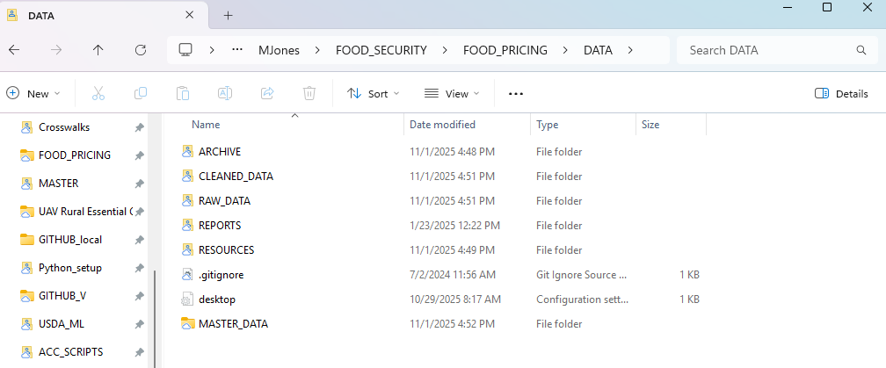

PROCESS IMPROVEMENT:
The new Scraping_Logs now have a “central_runner” with a complete timestamp and sequenceID. The central_runner refers to the Central Runner script.

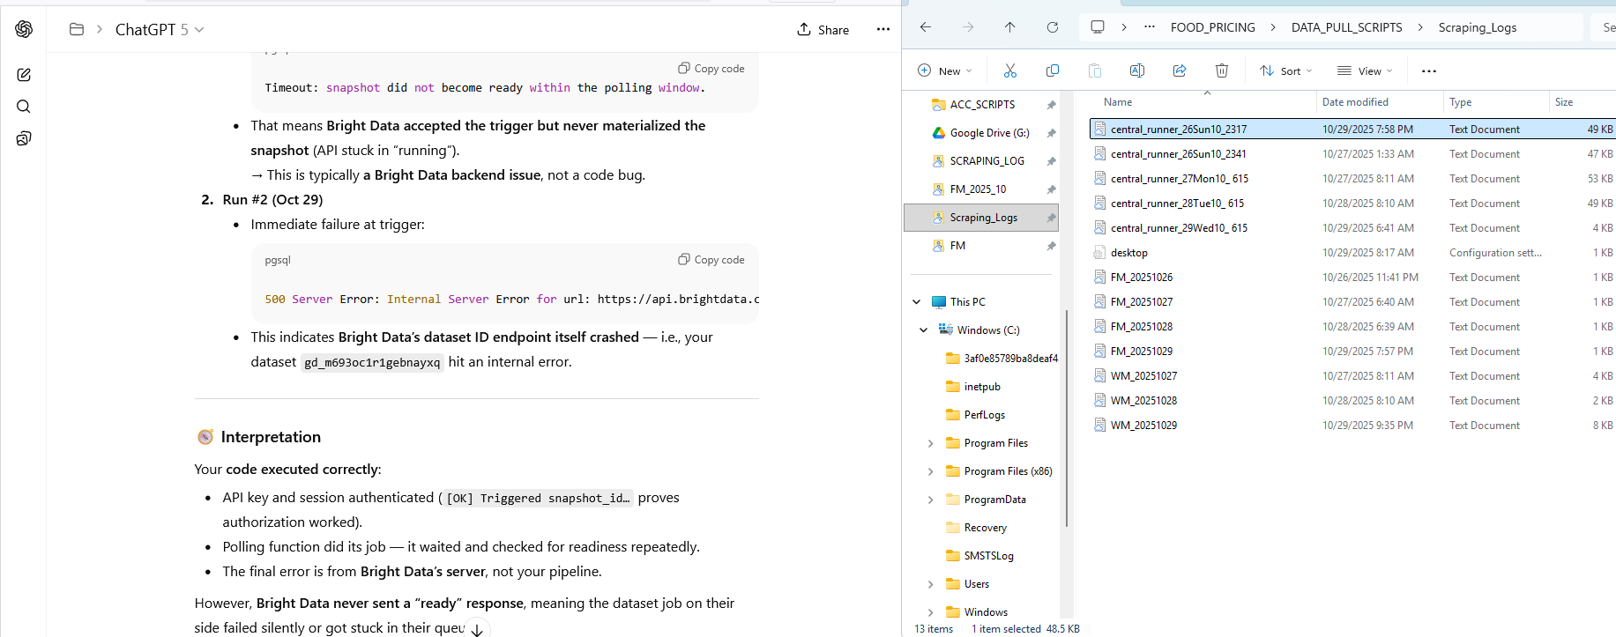

NEW LOCATION AND ARCHITECTURE
It’s best to isolate the data from other projects as much as possible. In addition the other drives are messy and frequently accessed by others so some isolation is protective and makes the paths shorter.

G:\.shortcut-targets-by-id\10hwxlrEnEox7VqS6tvo44Q8rX59qZcSg\Drones_MV\GITHUB\ISER\MJones\FOOD_SECURITY\FOOD_PRICING\DATA



